AFFIDAVIT OF SERVICE

FEDERAL COURT OF CANADA

BETWEEN:

Radu Hociung
Plaintiff, Appellant

and

Minister of Public Safety and Emergency Preparedness
Defendent, Respondent

AFFIDAVIT OF SERVICE

I, Radu Hociung, of the Solidaridad in the Quintana Roo state of Mexico, SWEAR THAT:

- I served the Minister Minister of Public Safety and Emergency Preparedness with Additional Written Submissions by sending a copy by fax on November 22, 2019 to Eric Peterson, solicitor for the Respondent at (416) 973-5004.

_____________________________
Radu Hociung

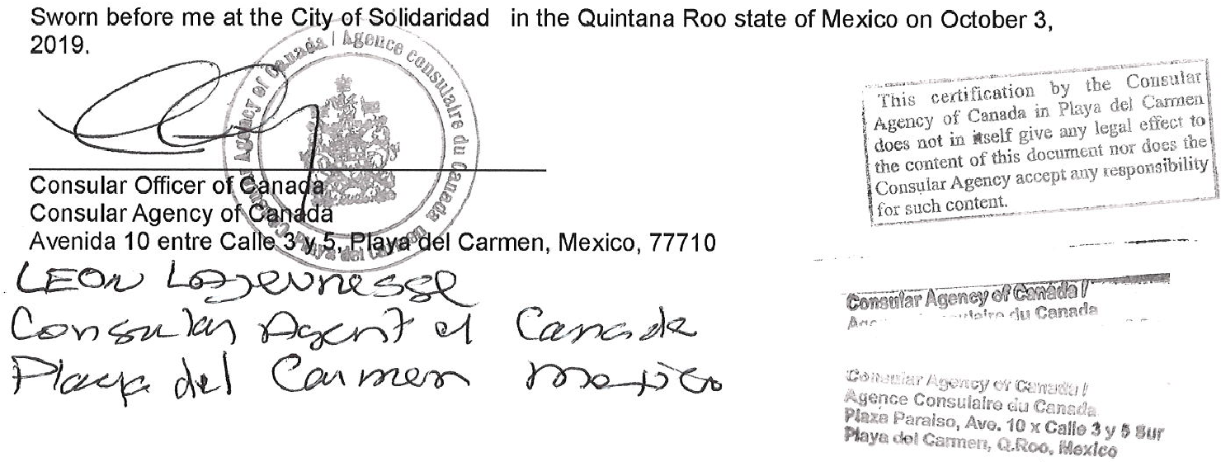
November 25,

